**Software Project Management (3171609)**

**{ JobLink-Up }**

**Submitted By**

|  |  |  |  |
| --- | --- | --- | --- |
| **Sr. No.** | **Enrollment No.** | **Name** | **Role/Responsibilities** |
| 1. | 200420116009 | Vaishnavi Patel | Team Leader |
| 2. | 200420116010 | Rohit Sonwane | Developer |
| 3. | 200420116011 | Neel Rana | Developer |
| 4. | 200420116019 | Dhwani Ladani | QA Tester |
| 5. | 200420116020 | Shiv Kadiwala | Developer |
| 6. | 200420116027 | Utsav Desai | QA Tester |

Department of Information Technology

Sarvajanik College of Engineering & Technology

Gujarat Technological University

**Version: 1.0 Date:11/09/2023**

**Aim: Understanding Software Requirement Specification**

**1.Introduction**

1.1 Purpose

* The Software is for finding a job for those who are less educated like 10th or 12th class. The people can register themselves and can apply to various companies and also the company can hire a candidate.
* This software solves the conventional problem as one would have to rush to find jobs who are having less education.
* This platform also solves the problem for companies who want to hire people for small works.
* The software takes various types of documents like photos, text, resume ,etc.
* Providing information about various types of roles that company requires.
* Providing the communication between the candidates and Companies.

1.2 Scope

* The software product proposed here is the Online Job Applying System for those who need a job and who need employees.
* The current system is mostly telephonic and paper-based and it is all for educated people. People coming from village areas and from distant places face the problems because of having a lack of knowledge about the availability of the job.
* Our goal is to solve the problem of being dependent on fulfilling a job and making everyone to be independent in this field, not only by providing the information and facilitating the process but also by saving time, money and effort through our software eventually resulting in retaining mental stability.
* To provide fast hiring to appropriate companies.

1.3 Definitions,Acronyms,and abbreviations

SRS :- Software Requirement Specification

OJCS :- Online Job Communication System.

DFD :- Data Flow Diagram

Admin :- Administration

1.4 References

* <https://timesofindia.indiatimes.com/readersblog/world-of-words/unemployment-in-india-34201/>
* <https://www.forbesindia.com/article/explainers/unemployment-rate-in-india/87441/1>

1.5 Overview

* This SRS is the requirements work product that formally specifies OJCS.
* It includes the results of both business analysis and system analysis efforts; various techniques were used to elicit the requirements and we have identified your needs, analyzed and refined them.
* The objective of this document therefore is to formally describe the system’s high-level requirements which includes functional requirements and non-functional requirements.
* Section 2 of this document provides an overview of the business domain that the proposed OJCS will support.
* Section 3 of this document provides an overview of the working of the System and requirements of its specifications.

**2.Overall Description**

2.1 Product Perspective

Our product is self-contained as most of the functionalities are developed within the system. It manages the data that companies want and data that candidates provide. Various stakeholders are involved in the Online Job Communication System for Companies and Candidates.

* Candidates
* Company
* HR
* Developer
* Product Managers
* Marketing and Sales Teams
* Data Privacy and Security Teams
* Support and Customer Service Teams

2.2 Product Functions

The software functions can be described as follows:

* Sign Up: When a candidate uses our app for its purpose, to keep track of his/her activity, we need to collect the details of the candidate and make it unique, so that s/he only sees what s/he wants. Same goes for the data flow for Companies.
* Candidate Hiring: If a Company wants to hire a candidate then this software will provide useful and valid information to both parties. We provide a feature for that purpose which will not only hire candidates but also the users will learn through this software and gain more information about the real world.
* Company Reputation: By using this software the company has the benefit of choosing the right candidate and gaining more profit. Also this feature will help the candidate to apply for the right most suitable job for their future.

2.3 User characteristics

Following are the different types of users which will be indulge in the project:

1. Admin:

Administrator is responsible for the data maintenance and data integrity of all the users. Some of the roles and responsibilities of the administrator are:

- Verifying users

- Maintaining payment gateway

- Taking care of relatable advertisements

- Responding to feedbacks

- Responding to flaws in system

2. The Company:

These are one of the most important stakeholders of the project. Companies are what our users are looking for; with correct, structured and organized information. Following are the characteristics of the Company:

* Provide information about Company.
* Provide information on the role that is needed for hire.
* Provide information about the hiring process.
* Provide information about Company’s working environment.

3. Candidate:

It’s that stakeholder which is going to use our platform for its own requirements. Hence, the information is required to cater to him/her in a more appropriate way. They have to provide correct and truthful data.

**3. Specific Requirements**

**3.1 Functional Requirement**

* Connect the Company with the right candidate.
* Maintaining the records of Candidates.
* Fetching the relevant information on display.
* Providing the information regarding the job roles from the company.

**3.1.1 Organizing the Requirements by Data Model ( Data dictionary, E-R Model, UseCase Model ):**

**E-R Model**

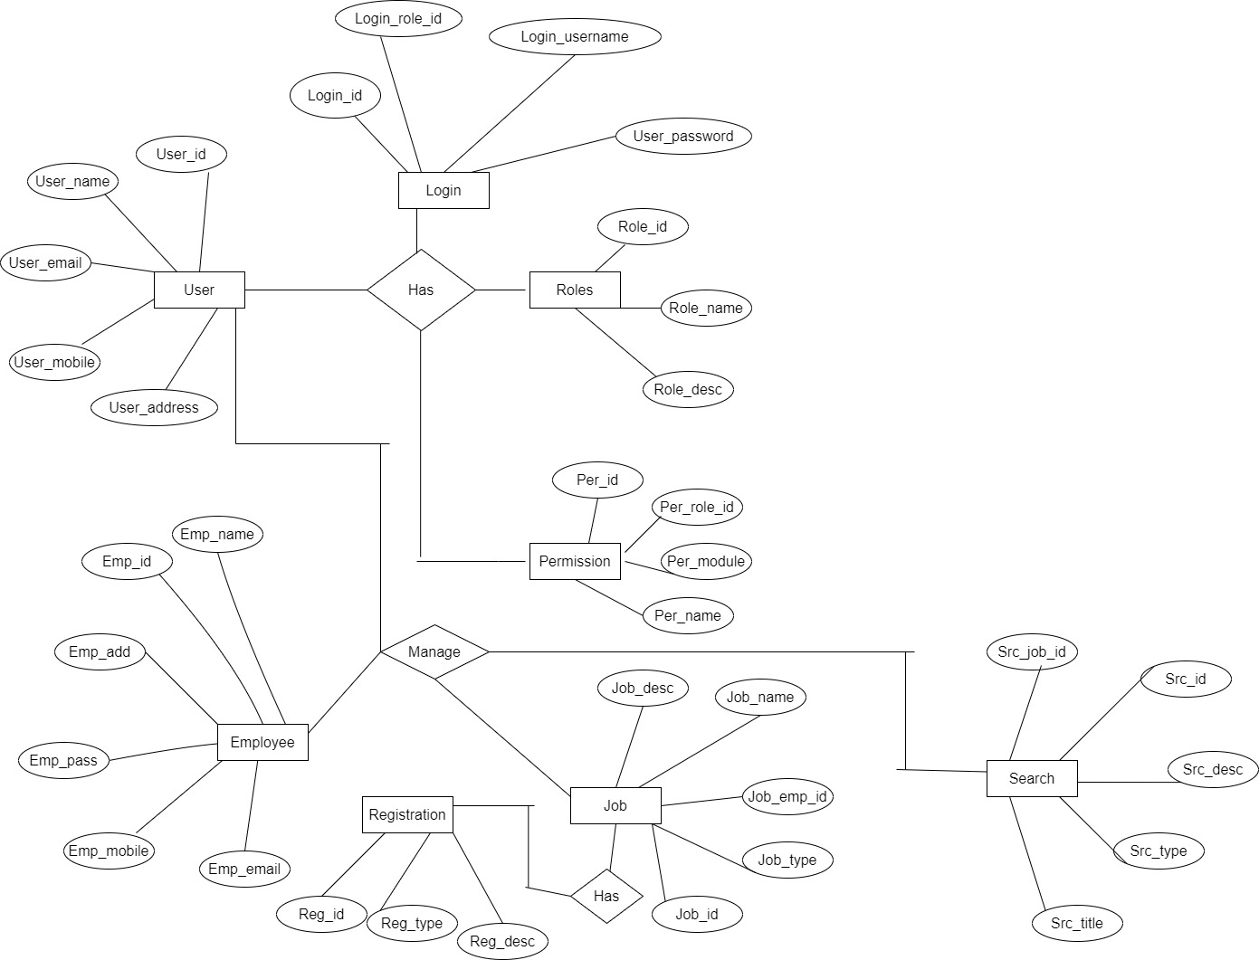

**Data Flow Model**

Level 0

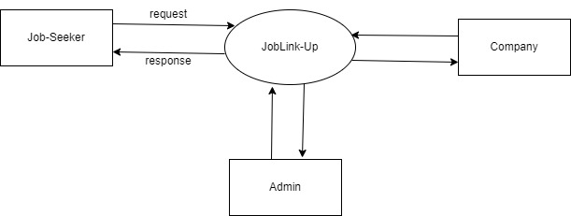

Level 1

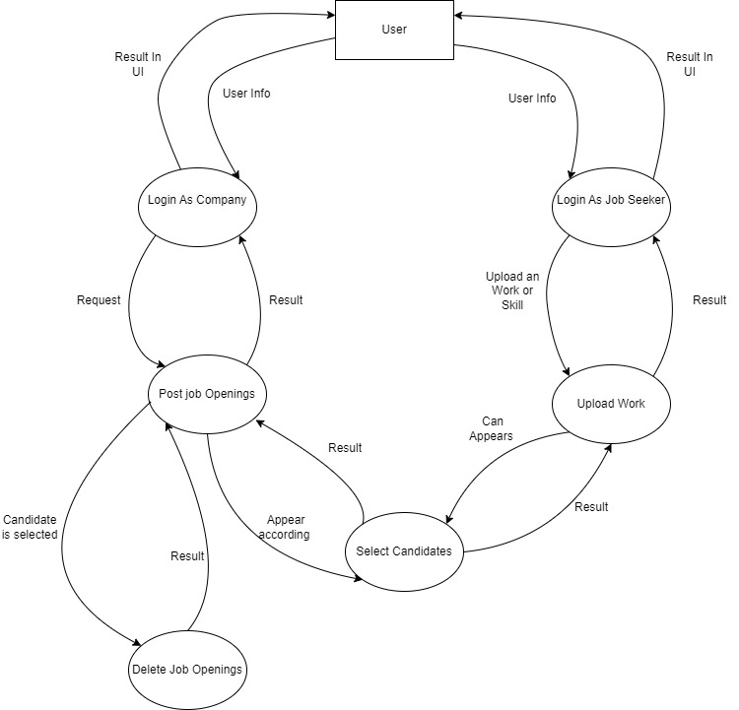

Level 2

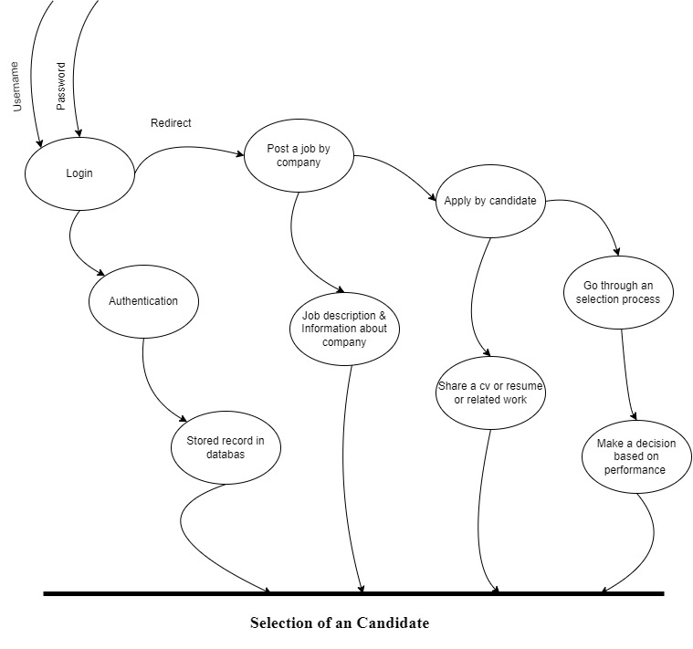

**UseCase Model**

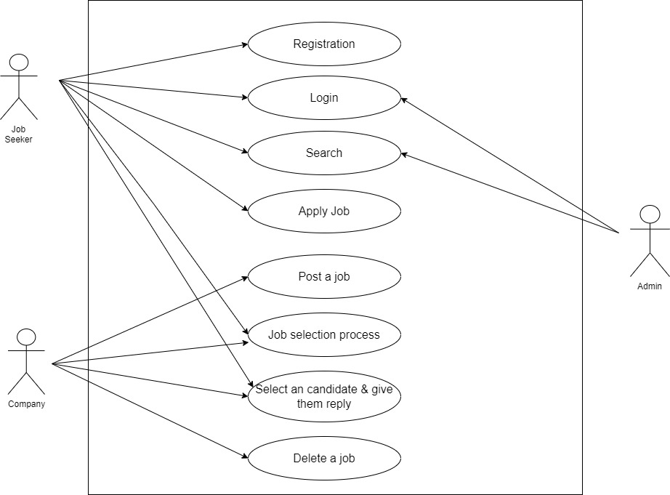

**3.2 Non-Functional Requirements**

Consumer’s unsaid requirements that indirectly states the organization’s value and standards for making a software, what are known as Non-functional requirements. Software is required to possess these properties which are as follows:

**3.2.1 Reliability**

Enough smartness is provided to system to catch that what is harmful/insecure for it and what is

required/secure for it, thus engaging itself to do work for longer time periods, defining the property “reliability”.

**3.2.2 Availability**

Flow of information updated or unchanged should remain linear and fast. Any delay in display of

changes made, might lead to uncertain flow of data or nonetheless data in the system. Hence, flow of data as per the requirements will ensure the Availability of information in a system.

**3.2.3 Security**

System should have required/standard verification checks for ensuring the security of itself and data; e.g., password and login to enter into the dashboard of a website, fingerprint scanner on mobile to unlock, etc.

**3.2.4 Maintainability**

System should be made as modular as it can fulfill the requirements. Maintenance should be done at regular time intervals to make the system reliable and secure with time. New security marks should replace/modify earlier marks to make security and authentication up to the mark.

**3.2.5 Portability**

Displaying or working of the system on one or more differently configured devices ensures the

portability of the software.